How to Create FHIR Jekyll Pages for Implementation Guides

Subheading

Published 10th Jan 2019

**Contents**

Overview 3

Basic Construction of Pages 3

Creating the Bundle Diagram 4

Tooling used for Bundle SVG File 4

Creating the Bundle Diagram 4

Final Editing Requirements 5

Creating the Markdown for Sections 6

Creating the Markdown Mapping Tables 6

Creating a Google Sheets Profile Template 7

Final Checks for the Created Template 11

Creating the Markdown from a Profile Template 11

Overview of template usage 11

Publishing the Guidance 12

Creating the Jekyll Pages 13

# Overview

This document gives guidance on how to create the Jekyll pages for use in the implementation guidance when using generic profiles and mapping tables to the data set to be sent. This guidance MUST be adhered to and developers MUST not use an alternative process to create the pages. It is acknowledged that the current process in not perfect and that there may be a better process, however due to time constraints the current process MUST be adhered to. Developers MAY feedback suggestions or issues with the current process at any time. This feedback will be considered if time and resources allow and this guidance updated where appropriate.

Important Note: This process in its current form does not meet Web Accessibility (WCAG 2.1) but will be included in the work to convert our products to be compliant with WCAG 2.1 when this work is undertaken.

# Basic Construction of Pages

For each page which represents a bundle a page will need to be created. The pages MUST follow a standard layout to ensure consistency etc. The basic format of a page is:

* Title – Generated from .md file
* Summary – Generated from .md file
* Table of Contents - Generated by Jekyll process
* Profile List – links to the FHIR servers
* Bundle Structure Diagram – Links to the resource mapping tables
* Resource Mapping Tables – link to each other

See Figure 1 for an example page:

* NHSD-Bundle-1

Figure 1

* NHSD-MessageHeader-1
* CareConnect-Organization-1
* CareConnect-Patient-1
* CareConnect-Encounter-1
* CareConnect-Procedure-1

Birth Details Bundle structure

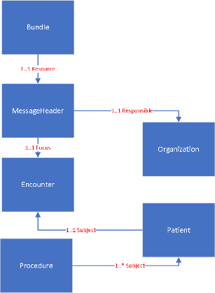

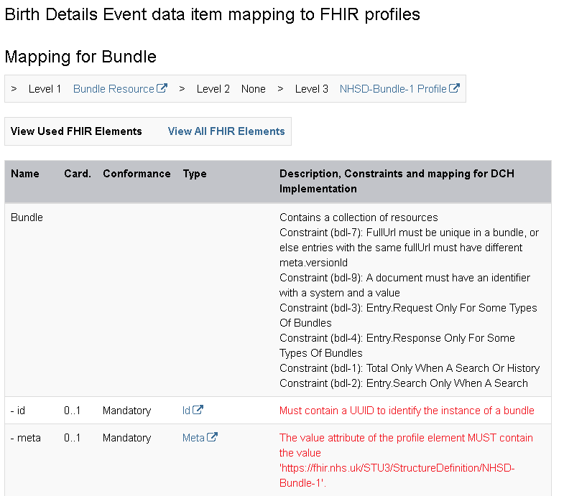

# Creating the Bundle Diagram

This section details how create the Bundle diagram

## Tooling used for Bundle SVG File

The Jekyll pages are generated using the standard Jekyll tooling which is not documented here. The following sections document the tooling used. Alternative should not be used unless approved by a technical lead and then the alternative tooling MUST NOT create artefacts which differ from artefacts produced by the recommended tooling.

## Creating the Bundle Diagram

The bundle diagram is an SVG file with the links to the resource tables. The SVG is created using VISIO. The diagram layout MUST be consistent for all pages in the specification to aid the reader. The diagram MUST have Bundle at the top, followed MessageHeader then the focus resource. The rest of the rest of the diagram should be layout out in a neat and consistent way for all pages. Example diagram Figure 2

Figure 2

The SVG MUST be edited in XMLspy (or a similar text editor) after creation to correct any inconsistency. The following points MUST be checked and fixed in the diagram prior to final publication .

The Visio diagram MUST be checked against these rules.

* The Visio diagram MUST use “Office Theme”
* The colour for the resource shapes MUST be “Blue Variant Accent 1”
* Resource shapes text MUST be “White” and centered
* Resource Shape MUST be 24 mm high and width 32 mm or larger for longer named resources.
* All text MUST be Calibri 10pt
* All Arrow text MUST be “Red”
* The arrows between resources MUST be “Blue Variant Accent 1”

## Final Editing Requirements

Once a Visio diagram is finished the following tweaks MUST be done in XMLspy

* Remove the line **<!DOCTYPE svg PUBLIC "-//W3C//DTD SVG 1.1//EN" "http://www.w3.org/Graphics/SVG/1.1/DTD/svg11.dtd**"> form the top of the SVG file.
* Edit the title elements in the connectors in XMLspy to equal the desc element for example **<title>Connector 1</title>** to **<title>1..1 resource</title>.** At time of writing this guidance. Visio does not seem to support editing this element so due to time constraints this is current process.
* Edit the title elements in the rectangles in XMLspy for example **<title>Rectangle</title>** to **<title> Click for how to map to Bundle</title>.** At time of writing this guidance. Visio does not seem to support editing this property so due to time constraints this is current process.
* The SVG file should be placed in the _includes/custom folder

# Creating the Markdown for Sections

The sections for each used resource have a heading of “mapping for” resource name for example Mapping for Encounter

The following text MUST be under this section:

How to populate the Encounter instance to conform to the profiles below:

This is followed by a one row table which indicates the level 1, 2 and 3 profiles the instance must conform to as below:

|  |  |  |  |  |  |
| --- | --- | --- | --- | --- | --- |
| **Level 1** | [Bundle Resource](http://hl7.org/fhir/stu3/bundle.html) | **Level 2** | None | **Level 3** | [NHSD-Bundle-1 Profile](http://xxx/) |

|  |  |
| --- | --- |
| **View Used FHIR Elements** | [**View All FHIR Elements**](https://nhsconnect.github.io/Generic-Test-Repo/explore_birth_details_all.html#mapping-for-bundle) |

Also a one row table to allow switching between all elements in the profile and just the utilised ones as below:

This switching is done by creating two pages one with the used elements only and one with all the elements. How this is done is shown in the creating markdown tables section.

Example markdown for these tables is below:

## Mapping for Patient ##

How to populate the Patient instance to conform to the profiles below:

|**Level 1**|[Patient Resource](http://hl7.org/fhir/stu3/patient.html)|**Level 2**|[CareConnect-Patient-1](https://fhir.hl7.org.uk/STU3/StructureDefinition/CareConnect-Patient-1/_history/1.1)|**Level 3**|None|

Note: the version number SHOULD be to the actual version used in the implementation.

|**View Used FHIR Elements**| |**[View All FHIR Elements](explore_birth_details_all.html#mapping-for-patient)**|

# Creating the Markdown Mapping Tables

The markdown tables are created using a cut and paste from the html of the rendered profiles from a browser and pasting into Google sheets to create a template. Once the template is complete in is saved as an Excel spreadsheet which can be imported back into Google sheets when further development is needed. This is then modified and updated to form a template from which the markdown is generated. The markdown is then added to the markdown file for the bundle. This section shows the process used to create a specific table and the rules to be followed. It is in two sections, the first is how to create a template from the profile html and the second is how to create a sheet to generate the actual markdown to be use in the Implementation Guide pages.

## Creating a Google Sheets Profile Template

### Step 1

The Profile html to be templated is opened in a browser (Note Google Chrome is the recommended browser). The Profile table in copied and pasted into a new Google sheet. Note: the expand all button needs to be selected if the rendered view has one and the snapshot tab.

The copy MUST be from the Name header to bottom of the table see below:

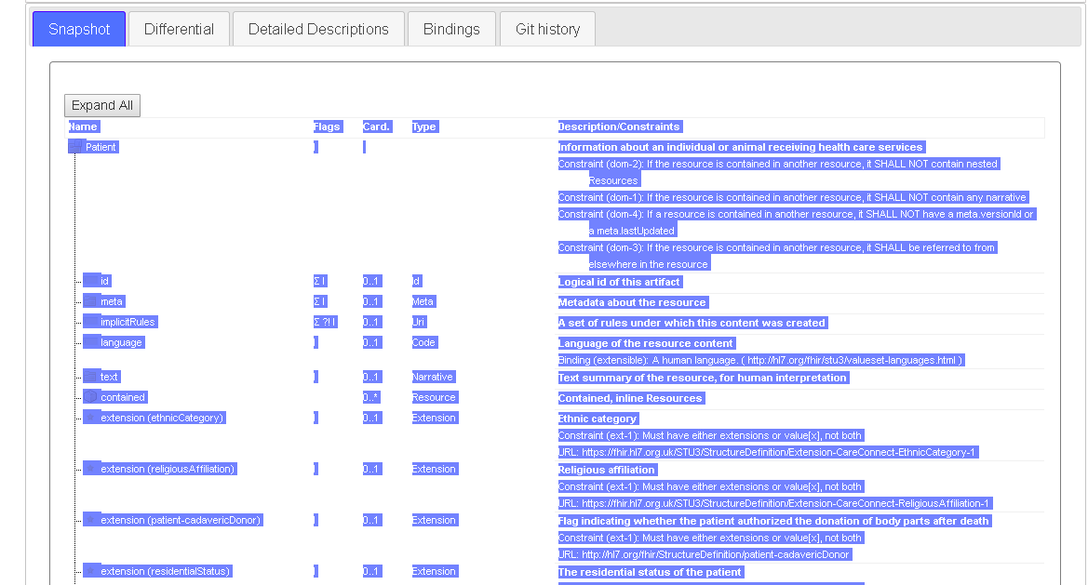

This is pasted in a new Google Spreadsheet

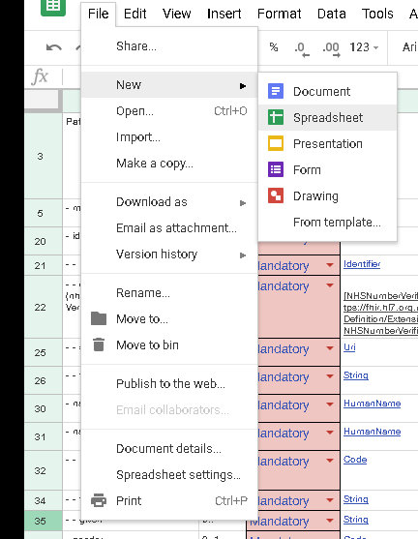

Then paste the copied html into the top left hand cell 1,A. This will create the starting point with all cells populated.

Next format the text to be wrapped by using format / text wrapping option. The format for template names is “NHSD-“ResourceName” or “ProfileName”-Template-1” for example: NHSD-CareConnect-Patient-1-Template-1

Name the sheet to the profile or resource name and include the full version number for example: CareConnect-Patient-1.1. The template spreadsheet may have other versions of the profile added on separate sheet in the same template at a later date.

### Step 2

Select column A and right click and select the unlink option.

### Step 3

Then for each row add a hyphen or number of hyphens based on the nesting of the element. Each hyphen is followed by a space. For example, see below

|  |
| --- |
| **Patient** |
| - meta |
| - identifier |
| - identifier (nhsNumber) |
| - - extension  (nhsNumber VerificationStatus) |
| - - system |
| - - value |

* meta is a child element of patient and therefore has – space
* identifier is a child of patient and therefore has – space
* identifier (nhsnumber) which is a slice also has – space
* the extension nhsNumberVerificationStatus is a child of identifier so has – space – space
* system and value are also children of identifier (nhsnumber) so have – space - space

This format has been chosen as it a simple indication of the nesting that works well with the markdown when the HTML is generated.

### Step 4

Select column B (with heading of Flags) and delete. Add a new sheet called Functions on that sheet add the following

|  |
| --- |
| Select |
| Mandatory |
| Required |
| Optional |
| Not Used |

in column A and first 5 rows. Then in the first sheet add a column with a header of Conformance as the third column. Select the first row of the new column which refers to a FHIR resource element and all other rows in the new column and right click and select data validation select list from range and select the range from the second (Functions) sheet. Select Show warning and then save. Then select the column again and add conditional formatting as shown below. This is to remind the user of the template that this field needs an appropriate value selecting.

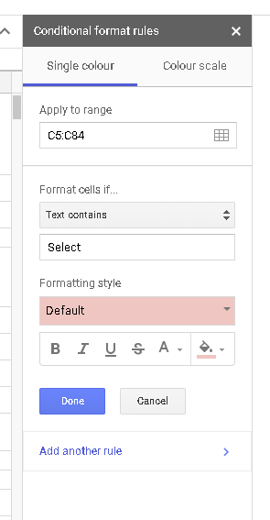

The template should have these all set to Select or Mandatory for Parent elements that have a cardinality of 1..1 or 1..*. Child elements that are 1..1 or 1..* should be selected when the parent element is used by the person using the template.

### Step 4

Note: ensure that the link points to the correct type and FHIR version see example below: On the fourth column (Type) for each cell select the cell and the link option and apply the correct link if there are any that are incorrectly linked.

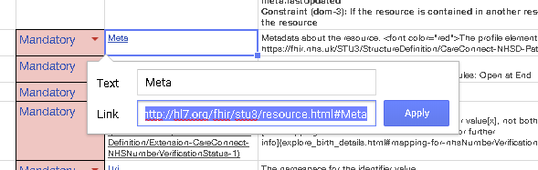

Exceptions to this process are for cells with have the follow usage:

* Extensions
* References
* Value[x]

These are treated differently as below:

**Extensions**

The text of “extension” and the hyperlink MUST be removed, and the name of the extension added instead along with a hyperlink to the correct extension version, this is available from the fifth column. This MUST be link to the URL of the extension i.e. to the FHIR server where the extension is published and MUST include the “Minor” version number too. See example below:

**Before**

|  |  |  |  |  |
| --- | --- | --- | --- | --- |
| - - extension (admissionMethod) | 0..* | **Select** | Extension | Additional Content defined by implementations Constraint (ext-1): Must have either extensions or value[x], not both URL: https://fhir.hl7.org.uk/STU3/StructureDefinition/Extension-CareConnect-AdmissionMethod-1 |

**After**

|  |  |  |  |  |
| --- | --- | --- | --- | --- |
| - - extension (admissionMethod) | 0..* | **Select** | [Extension-CareConnect-AdmissionMethod-1](https://fhir.hl7.org.uk/STU3/StructureDefinition/Extension-CareConnect-AdmissionMethod-1/_history/1.1) | Additional Content defined by implementations Constraint (ext-1): Must have either extensions or value[x], not both |

Extensions will have their own templates created i.e. treated the same as a profile.

**References**

Where there is a reference to another resource then the following MUST be done:

Add a new row for each permissible resource.

Then link the original type reference to the FHIR standard as per all other data types. Then for each permissible reference, link the reference which may be to a profile or a base resource to the correct link for the reference. For a profile this will be to the FHIR server where the profile is published and MUST include the Minor version number. For a base resource this will be to the FHIR standard resource page. See examples below:

|  |  |  |  |  |
| --- | --- | --- | --- | --- |
| - focus | 1..1 | Mandatory | [Reference](http://hl7.org/fhir/stu3/references.html) | The actual content of the message Constraint (ref-1): SHALL have a contained resource if a local reference is provided |
|  |  | Mandatory | [CareConnect-Encounter-1](http://careconnect-encounter-1/_History/1.1) |  |

Single reference

|  |  |  |  |  |
| --- | --- | --- | --- | --- |
| - individual | 0..1 | **Select** | [Reference](http://hl7.org/fhir/stu3/references.html) | Persons involved in the encounter other than the patient Constraint (ref-1): SHALL have a contained resource if a local reference is provided |
|  |  | **Select** | [CareConnect-Practitioner-1](https://fhir.hl7.org.uk/STU3/StructureDefinition/CareConnect-Practitioner-1/_history/1.1) |  |
|  |  | **Select** | [NHSD-RelatedPerson-1](https://fhir.hl7./etc) |  |

Multiple references

Value[x] is treated the same as a reference in that every type is put on a new row so that it can be made mandated option etc.

### Step 5

The Heading row MUST be made bold and the column 5 text changed from Description/Constraints to Description, Constraints and mapping for XXX Implementation. Note the XXX will be changed for the actual implementation name when the template is used.

For each cell in the fifth column the following changes need doing.

* For any values that are fixed in the profile the text that describes the fixed value needs to be added.
* All “|” characters MUST be replaced with “:” ( “|” is used in markdown)
* All links converted to markdown linking instead of html (this is to allow multiple links in a cell which is not support in Google Sheets)
  + For ValueSets use the ValueSet name

E.g. 

Or

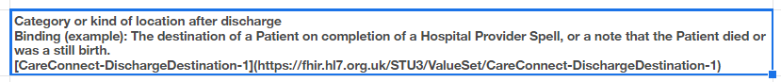

Or

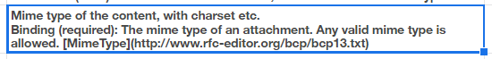

* Where a constraint has been made to remove a CodeableConcept choice e.g. Medications remove the default Valueset binding, e.g.

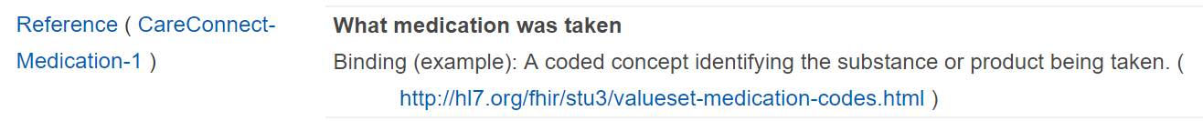

* All references to the FHIR standard have updated text ( See FHIR STU3 for further information etc..)
* Default text in the profile should not be deleted, as specific text for the template usage is added as supplementary text.
* All added text MUST be done in red using font color=’red’ to show added text (text not in the profile) Note: this MUST be done using these HTML tags so that it is carried though into the markdown.

#### Examples

|  |  |  |  |  |
| --- | --- | --- | --- | --- |
| - meta | 0..1 | Mandatory | [Meta](http://hl7.org/fhir/stu3/resource.html#Meta) | Metadata about the resource. <font color='red'>The value attribute of the profile element MUST contain the value 'https://fhir.nhs.uk/STU3/StructureDefinition/NHSD-MessageHeader-1'</font> |

The meta element

|  |  |  |  |  |
| --- | --- | --- | --- | --- |
| - - use | 1..1 | Mandatory | [Code](http://hl7.org/fhir/stu3/datatypes.html#code) | usual : official : temp : nickname : anonymous : old : maiden. Binding (required): The use of a human name. [CareConnect-NameUse-1]( https://fhir.hl7.org.uk/STU3/ValueSet/CareConnect-NameUse-1 )<font color='red'> MUST contain the value 'official'</font> |

A code element

|  |  |  |  |  |
| --- | --- | --- | --- | --- |
| - - extension (patient-birthTime) | 0..1 | Mandatory | [patient-birthTime](http://hl7.org/fhir/StructureDefinition/patient-birthTime) | The time of day that the Patient was born. This includes the date to ensure that the timezone information can be communicated effectively. Constraint (ext-1): Must have either extensions or value[x], not both [See mapping for patient-birthTime](explore_birth_details.html#patient-birthTime) for further infomation. |

An extension element

|  |  |  |  |  |
| --- | --- | --- | --- | --- |
|  |  | Mandatory | [CareConnect-NHSD-Encounter-1](http://CareConnect-NHSD-Encounter-1) | The focus resource in the bundle.<font color='red'> This MUST be to the encounter resource profiled as CareConnect-NHSD-Encounter-1. </font>[See mapping for encounter for further info](XXX#mapping-for-encounter) |

A reference element. Note: the link is only a default which will need to be updated when the template is used.to add the page name.

## Final Checks for the Created Template

* The template MUST not contain any “|” as these are used in markdown. The “|” MUST be replaced with “:”
* Generate the markdown using the template to check for syntax errors – this will mean the generation of markdown will fail due to links having carriage returns etc..
* Check the rendered HTML is as expected – i.e. add to a markdown file and generate using Jekyll.
* Ensure text for all cells is wrapped.

Once the final checks have been done the template MUST be saved as an Excel spreadsheet by using File/ Download as option. The Excel template is then upload to the Github Repo at “https://github.com/nhsconnect/Generic-Test-Repo/tree/gh-pages/Excel_profile_templates”

## Creating the Markdown from a Profile Template

The Excel template is imported into Google Sheets using the Import option and uploading the Excel template. The uploaded template is first renamed to a specific instance by adding the usage/domain name. For example: NHSD-Patient-Template-1 should be renamed to NHSD-Patient-Maternity-birth_details. Note: that the instance may need several different names if a resource is used across multiple pages which required different usage of the template. For example, where a resource has different contents or guidance for two different bundle types.

## Overview of template usage

* Column “A” MUST NOT be changed / edited
* Column “B” MAY be changed to align the cardinally with the business requirements providing it does not break the base resource – i.e. tightened but never loosened
* Column “C” MUST be changed to reflect the business requirement providing it does not break the base resource - i.e. tightened but never loosened. The rules are listed in the matrix below:

|  |  |  |  |  |
| --- | --- | --- | --- | --- |
| Drop down | Mandatory | Required | Optional | Not Used |
| Base Resource |
| Mandatory | Y (1..1 or 1..*) | N | N | N |
| Optional | Y (1..1 or 1..n) | Y (1..1 or 1..n) | Y (0..1 or 0..n) | Y |

Note the cardinally cannot be increased i.e. 1..1 cannot be 1..n 0..1 cannot be 0..n.

* Where an item is set to mandatory in the template to reflect the base resource conformance this MUST NOT be changed.
* Column D MUST not be edited changed
* Column E MUST have the specific guidance added and any mapping to the requirements data set. Specific text MUST be in red normal and the mapping in red bold as shown below.

2

1

The value that is unique. <font color='red'>MUST contain a valid NHS Number</font>  
<b><font color='red'>Maps to data set item NHS Number</font></b>

3

1 = Any annotation contained in the profile – SHOULD NOT be changed

2 = Template usage – SHOULD be added where required

3 = Mapping to data set – MUST be added where data set exists

## Publishing the Guidance

The completed template is published by running the option:

“Add-ons / MarkdownTableMaker / Convert the entire sheet to Markdown table”

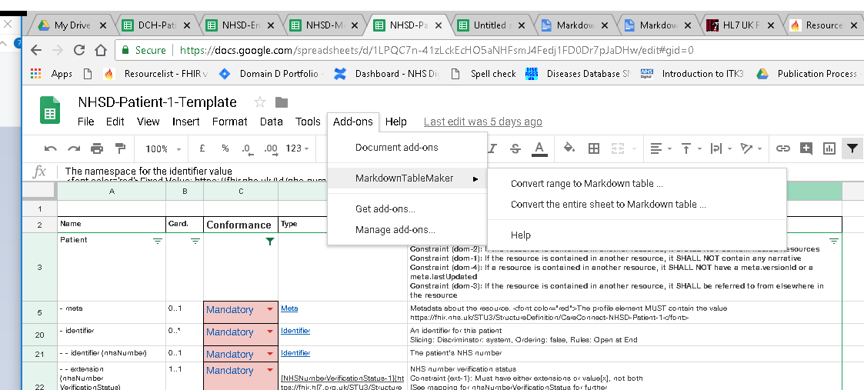

which creates the markdown which is pasted into the appropriate .md file in the implementation guide. This is done twice with filters added to give markdown for all FHIR elements and only used elements. This is done by filtering the sheet by “turn on filter” option.

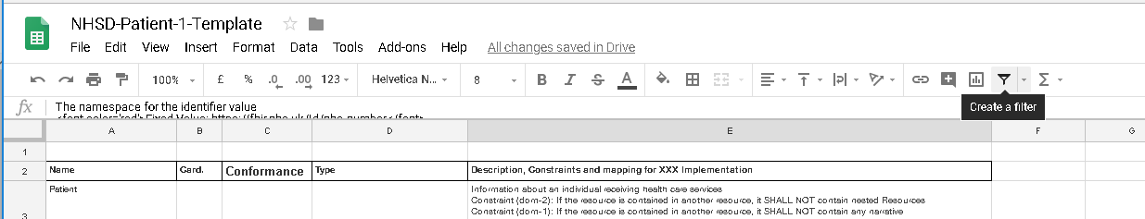

First set up the filter by:

* Create filter with the whole table selected with the exception of the header row
* This will add the filtering
* Select the conformance filter as below

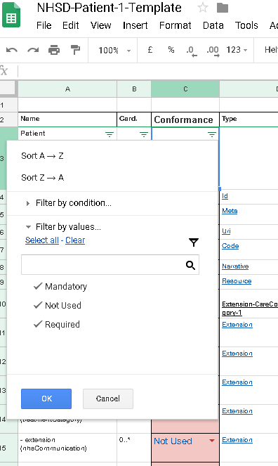

Select the filter for the usage of the template by unticking “Not Used”. This will allow the markdown to be generated for the used elements only.

Once the markdown has been generated the filter is removed and the markdown for all is generated.

## Creating the Jekyll Pages

The Jekyll pages are created using two pages for each bundle / event. One page has the used elements only for each resource mapping table and one has all elements for each resource mapping table. The link in each page just points to the other page.

The default view MUST be to the used only page which is referenced from the Jekyll sidebar. The all elements page is viewable only when user selected. For ease of use the following naming convention SHOULD be used.

explore_birth_details_all.html#mapping-for-patient

explore_birth_details_all.html#mapping-for-patient_all

Where the first is the used only and the second is the all page.

### Final Checks of Pages

The following final checks MUST be made to the rendered markdown

* Is table rendering correctly
* Do the references between tables work correctly, Note the header bookmarks are generated by Jekyll in the following format :
  + “Mapping for Patient” heading is generated as a bookmark of “mapping-for-patient” with capitals changed to lower case and spaces replaced with “–“
* Are links to correct FHIR artefacts and version of FHIR
* Are links to from diagram to correct resource tables
* Are all references to correct profiles on FHIR server
* Spellcheck the page
* Check that the added text is clear and gives sufficient guidance for an implementer to understand how to build to the profile for the use case.
* Check that all mappings to the data set are present and correct.

Once the development is finished the Google sheet MUST be saved as a Excel spreadsheet for use next time. This SHOULD be saved in the Repo that it was used for. It is suggested that a Source folder is added for this purpose.